Cost-push inflation and world input-output tables/Analyzing cost-push inflation using world input-output tables

Guillaume Daudin and Violaine Faubert

*This column analyses cost-push inflation using world input-output datasets (WIOTs). In the light of the recent surge in commodity prices, we analyze which countries are most vulnerable to energy-cost-push inflation. We document the exposure of Eastern and central European economies to a rise in Russian hydrocarbon prices. In a second step, we use WIOTs to document the heterogeneous reactions of consumer prices to exchange rate variations across countries, reflecting differences in foreign product content of consumption and intermediate products.*

With the rise of global value chains, numerous researchers have used world input-output tables (WIOTs) to shed light on international economics issues. These tables are helpful to measure exposure to international risk (Borin, Mancini and Taglioni, 2022), allocate carbon emissions across countries (Airebule, Cheng and Ishikawa, 2022) or look into the beneficiary of trade-generated income (Bohn, Brakman and Dietzenbache, 2021).

In a recent paper (Camatte et al., 2021), we use WIOTs to analyze cost-push inflation. Using several datasets covering most advanced and emerging economies, we perform an accounting exercise by way of large matrices inversions.

In this column, we use WIOTs to illustrate the vulnerability of Western economies to a rise in energy prices. We pay particular attention to country-specific exposures to Russian hydrocarbons.

# Vulnerability to hydrocarbon prices

Soaring commodity prices in the wake of Russia’s invasion of Ukraine have shed light on the vulnerability of Western economies to energy-price cost-push inflation. According to the International Energy Agency, Russia is Europe’s largest natural gas supplier, meeting 34% of the region’s demand in 2021. Germany is particularly vulnerable to an increase in Russian natural gas prices (Afunts, Cate, Helmschrott and Schmidt, 2022).

Using the WIOD database, we illustrate which countries are most affected by a rise in energy prices. Our accounting approach aims to illustrate interdependencies and vulnerabilities to cost-push inflation. Hence, we do not intend to assess the economic impact of the war in Ukraine. Such an assessment would require in-depths studies with much more sophisticated behavioral assumptions to account for product substitution and price adjustments.

Figure 1 represents the elasticity of consumer prices to a shock on energy prices, with a focus on the impact of a shock on Russian hydrocarbon prices.

The impact of a shock on Russian hydrocarbon is negligible for the USA, which is broadly self-sufficient in energy and only imports 7% of its oil from Russia. The price impact is also limited for the UK, which imports less than 10% of its oil and gas from Russia. By contrast, for the Netherlands, Italy and Germany, which import around one-third of their oil and gas from Russia, Russia accounts for close to 20% of the total impact of an energy price shock. The impact of a rise in Russian hydrocarbon prices is even higher for Eastern European countries such as Finland, Lithuania and the Slovak Republic, which import more than 80% of their oil and gas from Russia.

Figure 1 : Vulnerability of consumer prices to a rise in hydrocarbon prices and Russian hydrocarbon price increases, WIOD

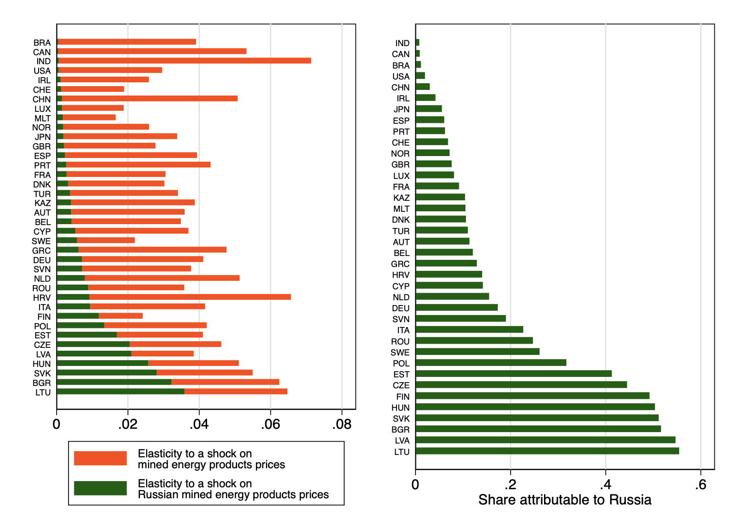

Source: WIOD, author’s calculations.

A caveat is that our computations rely on the latest version of WIOD, which was published in 2016 and might not represent recent shifts in global trade. In the paragraph below, we explain how we developed a simple accounting tool to fill the data gap for the most recent years.

# Elasticity of consumer prices to exchange rate variations over two decades

Besides shedding light on the country-specific impact of cost-push inflation, world input-output tables are also helpful to illustrate how exchange rate movements affect inflation. The transmission of exchange rate movements differs across countries. It depends, among other things, on their respective trade openness, the relative integration of sectors and firms in international production chains and the currency of invoicing for trade. In a recent paper (Camatte et al., 2021), we analyze the impact of exchange rate variations on domestic consumer prices using several WIOTs datasets covering two decades, from 1995 to 2019.

In line with the existing literature, we find that in response to a 1% appreciation of the domestic currency, domestic consumer prices decrease by around 0.10% on average at the world level. The impact of exchange rate variations on consumer prices has remained broadly stable over the past two decades.

Our results are likely an upper bound. Indeed, our accounting approach relies on the simplifying assumption that exchange rate fluctuations completely pass-through to import prices. However, a large body of literature suggests that the pass-through is incomplete, even in the long run, as a result of slow nominal price adjustments or the pricing-to-market behavior of firms. Using alternative assumptions would thus entail lower estimates. Nevertheless, our accounting approach is useful to compare the vulnerability of different economies to an exchange rate shock.

Figure 2 shows that our findings are robust to using two different datasets (i.e. TiVA from the OECD and WIOD). We also show that a precise assessment of the impact of exchange rate variations on consumer prices can be estimated without resorting to world input output tables. The construction of World Input-Output tables is data-demanding and WIOTs are typically released with a lag of several years. As a result, most WIOTs are not available for the most recent years. To fill the data gap, we extrapolate the impact of exchange rate variations on consumer prices using up-to-date GDP and trade statistics on imported consumption and intermediary goods. The dotted line on Figure 2 shows that we obtain a reliable estimate. We thus provide a simple accounting tool to estimate the elasticity of consumer prices to the exchange rate for the most recent years.

Figure 2: Elasticity of domestic prices to exchange rate shocks.



Sources: WIOD, TIVA, World Bank, BACI and Camatte et al. (2021)

# Heterogeneity and channels of the effect of exchange rate variations on consumer prices

Depending on the country, the impact of a 1% exchange rate fluctuation on domestic prices ranges from 0.05% to 0.22%, reflecting different degrees of openness to trade and differences in foreign product content in domestic consumption.

Figure 3 shows that the elasticity is lower for large advanced and developing countries. For instance, we find an elasticity of 0.06 for the US.

Within the euro area, the elasticity of domestic consumer prices differs substantially.

It ranges from 0.07 in Italy to 0.18 in Ireland, a small open economy with a large traded sector and a large share of trade outside the euro area. For larger countries (France, Germany, Italy and Spain) and countries whose trade is concentrated with euro area partners (such as Portugal and Greece), the elasticity is close to 0.10, reflecting a lower degree of openness to trade. The elasticity is twice higher for small open economies like Luxembourg, Malta, Slovakia and Ireland.

The value of the elasticity is closely, but not perfectly, related to the share of imported goods and services in household consumption. Overall, the higher a country’s import share in consumption, the higher the elasticity of domestic consumer prices to the exchange rate.

Figure 3 Elasticity of consumer prices to a shock in the domestic currency



We also analyze the role of global value chains in the transmission of an exchange rate appreciation. We identify four channels through which an exchange rate appreciation impacts consumer prices when production processes are global:

* the price of imported final goods sold directly to domestic consumers;
* the price of imported inputs entering domestic production;
* the price of exported inputs feeding through imported foreign production;
* changes in domestic and foreign production costs in turn pass through to the price of inputs for domestic and foreign goods, causing further production costs variations through input-output linkages.

Figure 4 shows that the first two channels explain three-quarters of the transmission of an exchange rate appreciation to domestic prices. The last two channels, which reflect the impact of participation in global value chains, play a limited role, with marked across-countries heterogeneity.

Figure 4 : Channels of the exchange rate shock effect on consumer prices (WIOD, 2014)



# Bibliography

Airebule, P, H Cheng, J Ishikawa (2022), “Shared responsibility criterion for allocating carbon emissions across countries”, VoxEU.org, 28 February

Bohn, T, S Brakman and E Dietzenbacher (2021), “From gross exports to value-added exports to income exports”, VoxEU.org, 15 June (https://voxeu.org/article/gross-exports-value-added-exports-income-exports)

Borin, A, M Mancini and D Taglioni (2022), “Integration if global value chains might not increase exposure to risk after all”, VoxEU.org, 1 March (https://voxeu.org/article/integration-global-value-chains-might-not-increase-exposure-risk-after-all)

Dietzenbacher, E, B Los, R Stehrer, M Timmer and G. de Vries, G. J. (2013). “The Construction of World Input-Output Tables in the WIOD Project.” Economic Systems Research, 25(1):71–98.

Afunts, G, M Cato, S Helmschrott, T Schmidt (2022) “Russia’s invasion of Ukraine has led to higher inflation expectations of individuals in Germany”, VoxEU.org, 20 April

Boz, E, C Casas, G Georgiadis, G Gopinath, H Le Mezo, A Mehl, and T Nguyen (2020), “Patterns in invoicing currency in global trade”, VoxEU.org, 9 October.

Boz, E, G Gopinath and M Plagborg-Moller (2018), “Global trade and the dollar”, VoxEU.org, 11 February.

Camatte, H, G Daudin, V Faubert, A Lalliard and C Rifflart (2021), "Estimating the elasticity of consumer prices to the exchange rate: an accounting approach", ECB Working Paper No 2610 / October 2021.

Timmer, M, E Dietzenbacher, B Los, R Stehrer, and G J de Vries (2015), "An Illustrated User Guide to the World Input–Output Database: the Case of Global Automotive Production" , Review of International Economics., 23: 575–605

Timmer, M. P., Los, B., Stehrer, R., and de Vries, G. J. (2016), "An Anatomy of the Global Trade Slowdown based on the WIOD 2016 Release," Technical report.